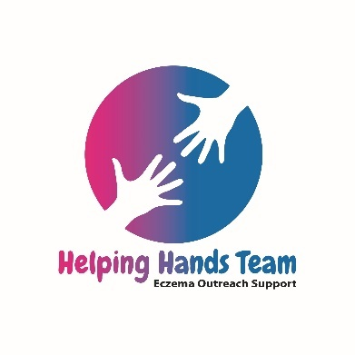
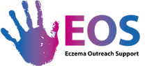

Development Services Helping Hand
Role Title | Development Services Helping Hand
Payment | This is an unpaid position. Travel expenses will be refunded.
Eczema Outreach Support | Eczema Outreach Support exists to help families deal with the practical and emotional aspects of having a child with eczema. At the heart of our service is the opportunity for families to connect with others in the same situation, get reliable information and to speak to people who understand.
Outline of Role | This role involves:  - Helping with our welcome packs (making up, mailing out, taking stock)  - Various office and administrative tasks such as mail shots, printing and other duties.  - Supporting the Development Team with additional projects.
Skills, Attitude, Experience | We are looking for someone who believes in the support and services EOS offer and is passionate about helping others. The volunteer should be:  - Reliable  - Trustworthy,  - Have good time keeping skills  - Enjoy working in a busy office as part of a team  - No previous administration experience is required.
Benefits to Volunteer | - Valuable experience for your CV.  - Free training  - A Reference for any future volunteering or employment roles  - Being part of an organisation that makes a difference  - Volunteer pack including your own EOS t-shirt
Where | The role will be based in Eczema Outreach Support main office:  129 High Street, Linlithgow, EH49 7EJ
When | We would require a minimum of 1-2 hours per week. The office is open every day apart from a Friday, so the day of the week and time can be flexible (between 9am – 5pm).
Support | Volunteer Training and ongoing support offered.
How to apply | If you would like to apply for this role, you should complete our application form found here.  Candidates will then be offered an interview
Questions | If you have any questions about this role, you should get in touch with Lyndsay Noon lyndsay@eos.org.uk for an informal chat

