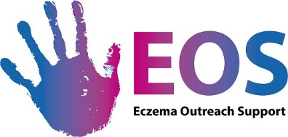

Gift Aid Declaration Form (for past, present and future donations)
If you are a UK taxpayer, Eczema Outreach Support can reclaim the tax you have paid on every donation you make. For every £1 you give we can claim up to 25p back from the HM Revenue & Customs at no extra cost to you.

- Please complete the details below and tick the relevant box below.

Title (Mr, Mrs, Miss, Ms):

Surname: Forenames:

Home address:

Postcode:

Phone:

Email:*

* If you are happy for EOS to contact you by email, please enter your preferred email address above. You can unsubscribe at any time.

- If you are a UK taxpayer, please tick the first box so we can claim up to 25p for every £1 you give at no extra cost to you. Please note that we can only claim the Gift Aid on the gifts which are your own money and not on those which are a collection, unless each donation is on a different form with the donors’ details.

☐ Yes, I am a UK taxpayer and would like EOS to reclaim the tax on any of the donations I have made in the last four years and any future donations I may make*
Date ______ / ______ / ______
☐ No, I am a non-taxpayer.

*To qualify for Gift Aid, you must pay an amount of UK income tax and/or capital gains tax at least equal to the tax that EOS will reclaim on your donations in the appropriate tax year (6 April one year to 5 April the next).

Please notify EOS if you want to cancel this declaration or you change your name and/or address.

- Please return to:

Eczema Outreach Support, Bryerton House, 129 High Street, Linlithgow, EH49 7EJ
Email: info@eos.org.uk

EOS a registered charity Scotland (SC042392) www.eos.org.uk

